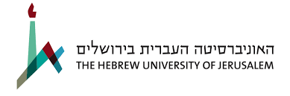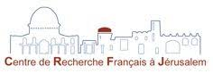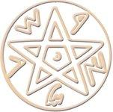

SAVE THE DATE!

February 20-23, 2023

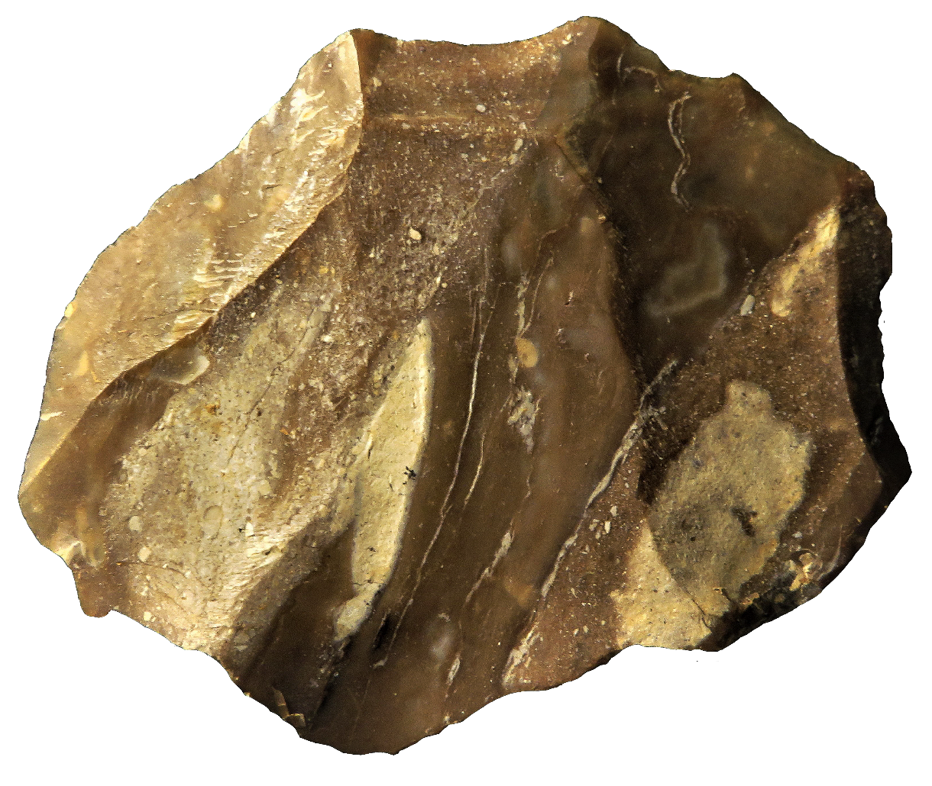
French-Israel workshop: Technology of the flint knapping
Organized by the Institute of Archaeology, the Hebrew University and Centre de Recherche Français à Jérusalem (CRFJ)
Program: Flint knapping demonstrations, theory, discussions and hands-on workshop on archaeological material. The workshop will focus on the Levallois and blade knapping systems.

Participants:
PELEGRIN Jacques and MEIGNEN Liliane (CNRS)
BRENET Michel (INRAP)
ZAIDNER Yossi, GORING-MORRIS Nigel and PREVOST Marion (HUJI)
MARDER Ofer (BGU)

Two credits course open to MA and 3rd year BA students from all universities in Israel
A detailed program will be available soon.
Contact: Yossi Zaidner: yzaidner@mail.huji.ac.il

